MODULE 4 – INTRODUCTION TO DBMS

LAB EXERCISES

16. SQL Stored Procedure
Lab 1.
Write a stored procedure to retrieve all books by a particular author.
Ans.
Create stored procedure
1. DELIMITER //

CREATE PROCEDURE get_books_by_autthor(IN author_name varchar(255))

BEGIN

SELECT * FROM books WHERE author = author_name;

END //

DELIMITER ;
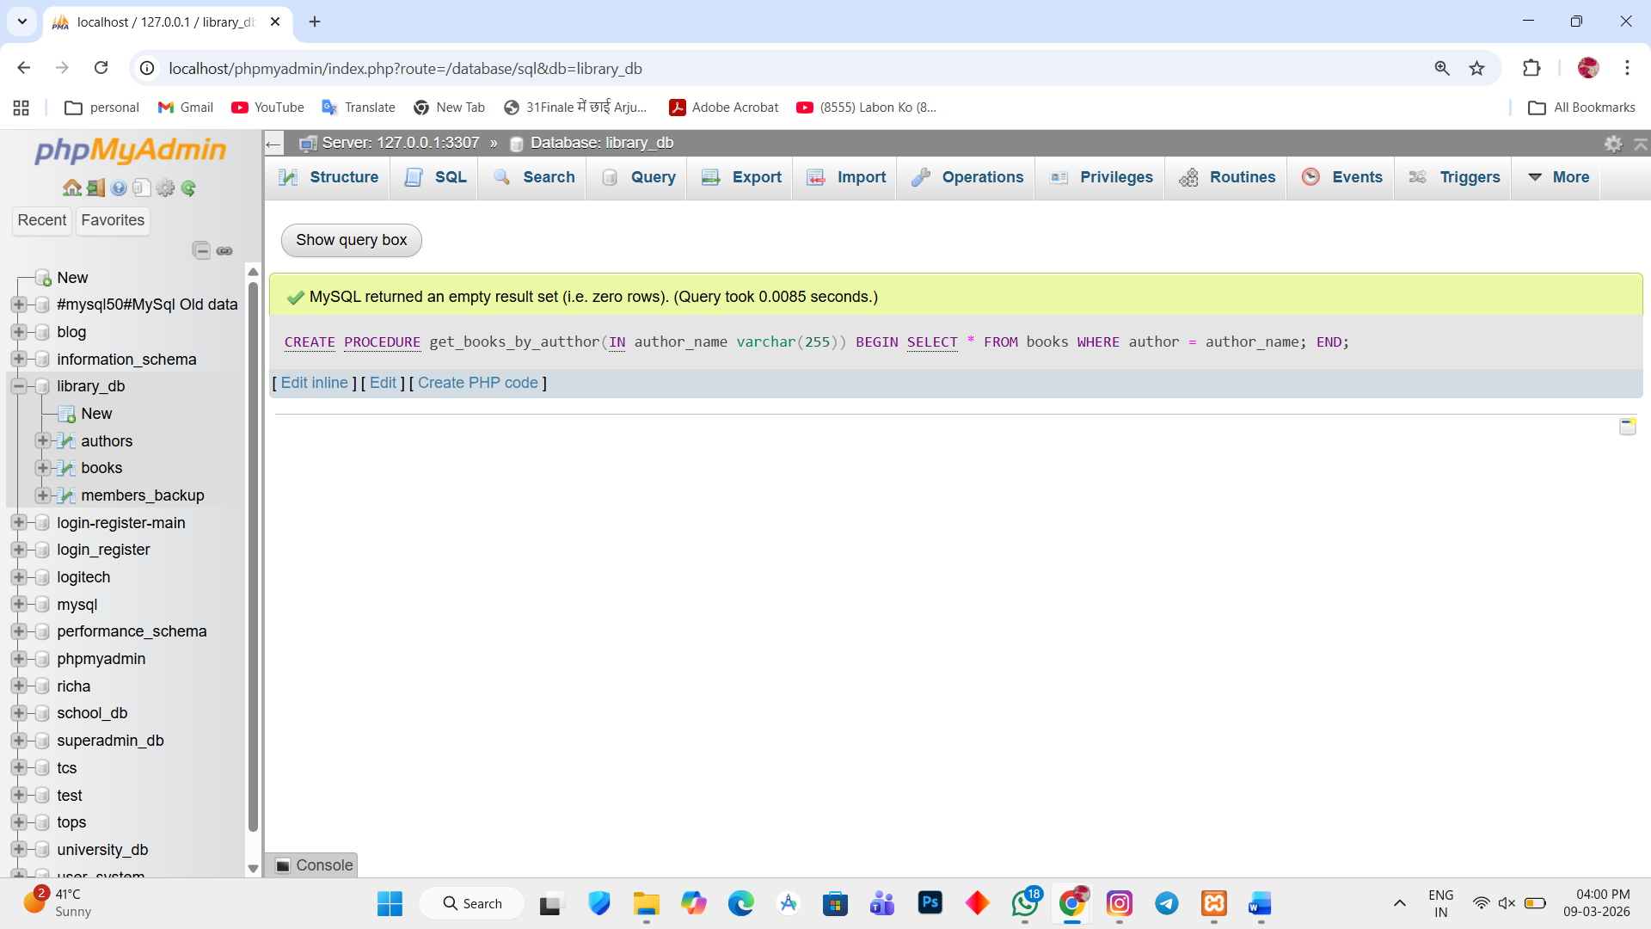

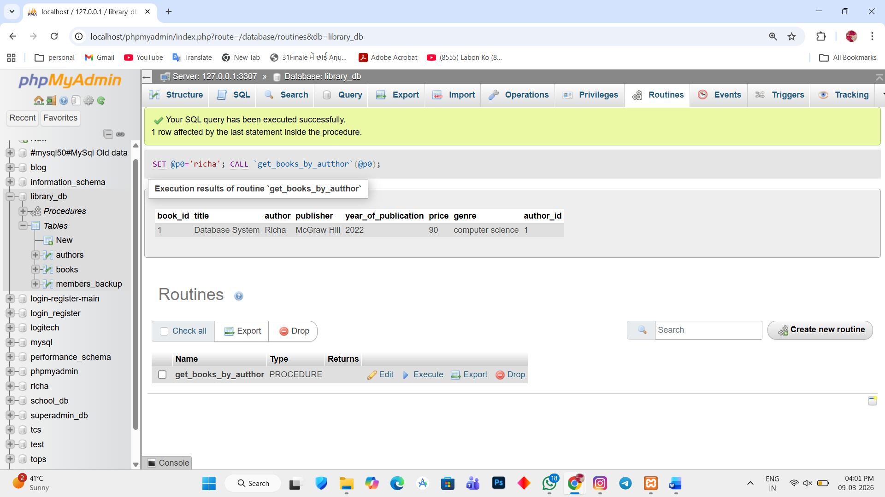

Lab 2.
Write a stored procedure that takes book_id as an argument and returns the price of the book.
Ans.
1. DELIMITER //

CREATE PROCEDURE get_book_price(IN bid int)

BEGIN

SELECT price FROM books WHERE book_id = bid;

END //

DELIMITER ;
